Model 1402 Low Energy Ion Gun
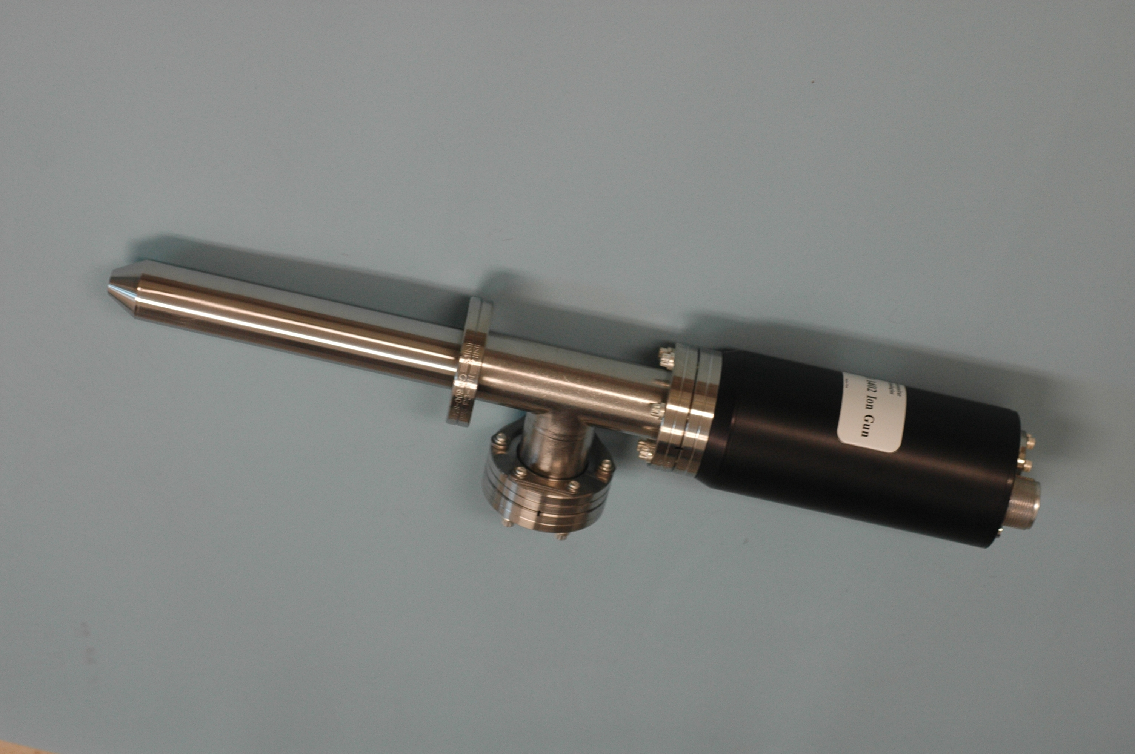

Design Features

- Focusing column optimized for low energy throughput
- High brightness electron impact source for maximum bulk material removal
- Emission regulated bombardment provides stable ion current with front panel adjustable dynamic range x300
- Continuously variable beam energy up to 5keV
- Replaceable beam trimming aperture with typical life-time of > 500 hours
- Dual filaments provide operational backup with typical filament life-time > 500 hours
- All UHV compatible and etch resistant materials used in fabrication
- Differential pumping to minimize main chamber gas loading
- Operates over the range of inert gas species, Oxygen with optional Thoria filament

Guaranteed Performance @ 20mm Working Distance, Argon Ions

Energy Spot Size Beam Current Current Density
(um FWHM) (mA/cm²)
3kV 400 8uA 4.0
1kV 750 5uA 1.1
500eV 1000 4uA 0.50
100eV 1000 2uA 0.25

Model 1403 Ion Gun Schematic
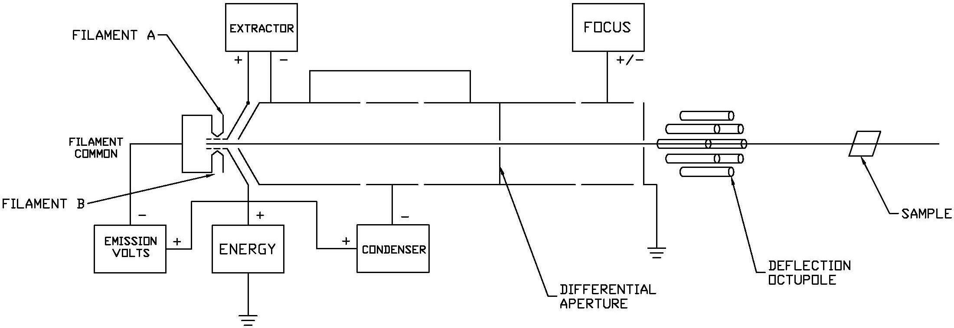

Engineering Specification

Working Distance: 20 mm
Beam energy: 10eV to 5keV continuously variable
Raster Size: 7 x 7 mm (minimum)
Mounting Flange: 70 mm (2.75in) O.D. CF
Differential Pumping: 70 mm (2.75 in) O.D. CF
Supply Gas Inlet: 34 mm (1.33 in) O.D. CF
Source gases: He, Ne, Ar, Kr, Xe
Bake-out Temperature: 100 °C maximum

System Integration Details
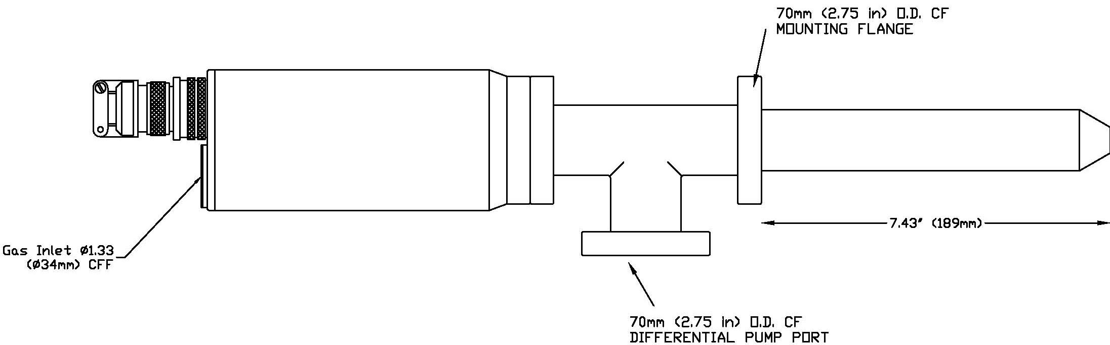

1402A Controller Features

- Precise and stable lens voltages
- Emission regulated electron impact supply
- Front panel raster controls with external programmability
- Power interlocks for safety and equipment protection
- Remote On/Off control for automated operation from external equipment
- Raster compensation electronics to correct for changes in sample geometry and working distance
- Comprehensive front panel system parameter monitoring

Controller Specification

Input Power: 115/230VAC 50/60Hz auto-select operation. Fused at 3.3/1.8A.
Beam Energy: 0 - 5000V, 1mA switch mode supply continuously variable.
Output capacitance: 0.0047μF.
Condenser Focus: 0 - 1500V, 1mA switch mode supplies independently and continuously variable through front panel three position rotary switches and trim-pots. Output voltages scale with energy. Output capacitance: 0.0047μF
Objective Focus: 0 - 5000V, 1mA switch mode supply continuously variable. Output voltage scales with energy. Output capacitance: 0.0047μF
Filament Power: Emission regulated supply with front panel selectable filaments providing 5V@
5A max.
Electron Bombardment Electron accelerating voltage internally adjustable to 150V.
Seven settings of electron emission current selectable from front panel rotary switch.
Ion Extraction: Internally adjustable to 1500V.
Deflection: Variable bi-polar 350VDC supply for +X, -X, +Y and -Y deflection. Remaining octupole elements are supplied from a resistive divider network.
Interlocks: HV cable disconnection turns off HV supplies.
Adjustable high pressure interlock switches off HV supplies in the event of system overpressure.
System and Auxiliary interlocks provide total shutdown in the event of system or auxiliary equipment failure.
Front Panel Monitoring: Digital panel meters provide precision monitoring of all critical parameters including;
lens voltages (4¹/₂ digits), ion source pressure and beam current (3¹/₂ digits), filament current and voltage (3¹/₂ digits), emission current (3 ¹/₂ digits).
Chassis Dimensions: 483(W)x132.5(H)x435.4(D) mm. 19 inch rack-mountable desktop case 3U high.

Typical Performance Data

