Model 1403 TOF-SIMS / Bulk Etch Ion Source
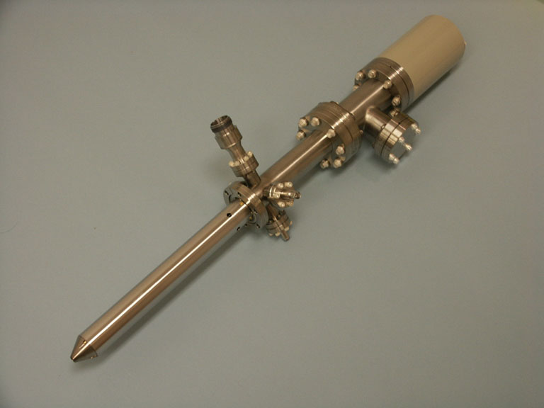

Design Features

- High brightness electron impact source for maximum bulk material removal
- Emission regulated bombardment provides stable ion current with front panel adjustable dynamic range x300
- Adjustable spot size from 20 μm to > 1 mm for spatially defined sputtering
- Continuously variable beam energy up to 5keV
- Neutral species suppression using beam bending optics
- Beam blanking capability for TOF SIMS
- Integral beam current monitoring capability
- Replaceable beam trimming aperture with typical life-time of > 500 hours
- Dual filaments provide operational backup with typical filament life-time > 500 hours
- Internal source pressure sensor permits monitoring of ion source pressure
- All UHV compatible and etch resistant materials used in fabrication
- Pre-objective lens deflection for reduced spot size
- Differential pumping to minimize main chamber gas loading
- Operates over the range of inert gas species

Guaranteed Performance @ 5.0 keV Ar Ions

Mode | Spot size  (μms) | Beam Current | Current Density (mA/cm²)
Large Spot | 250 | 15μΑ | 30
Small Spot | 20 | 300nA | 95

Model 1403 Ion Gun Schematic
Engineering Specification

Working Distance: 35 mm ^{see note 1 below}
Neutral Species Suppression: 3° Electrostatic bend optics
Beam energy: ≤ 5keV continuously variable
Raster Size: 4 x 4 mm (minimum)
Mounting Flange: 70 mm (2.75in) O.D. CF
Differential Pumping: 70 mm (2.75 in) O.D. CF
Supply Gas Inlet: 34 mm (1.33 in) O.D. CF
Source gases: He, Ne, Ar, Kr, Xe
Bake-out Temperature: 150 °C maximum

Note 1: Figure 1 shows typical focus conditions at other working distances

System Integration Details

70 mm (2.75 in) O.D. CF MOUNTING FLANGE

9.842 in. (250 mm)
GAS INLET, 33mm (1.33in)
O.D. CF FLANGE
70 mm (2.75 in) O.D. CF DIFFERENTIAL PUMP PORT

1403A Controller Features

- Precise and stable lens voltages
- Emission regulated electron impact supply
- Front panel raster controls with external programmability
- Power interlocks for safety and equipment protection
- Remote On/Off control for automated operation from external equipment
- Raster compensation electronics to correct for changes in sample geometry and working distance
- Comprehensive front panel system parameter monitoring

Controller Specification

Input Power: 115/230VAC 50/60Hz auto-select operation. Fused at 3.3/1.8A.
Beam Energy: 0 - 5000V, 1mA switch mode supply continuously variable.
Output capacitance: 0.0047μF.
Dual Condenser Focus: 150 - 5000V, 1mA switch mode supplies independently and continuously variable through front panel three position rotary switches and trim-pots. Output voltages scale with energy. Output capacitance: 0.0047μF
Objective Focus: 0 - 5000V, 1mA switch mode supply continuously variable. Output voltage scales with energy. Output capacitance: 0.0047μF
Filament Power: Emission regulated supply with front panel selectable filaments providing 5V@
5A max.
Electron Bombardment Electron accelerating voltage internally adjustable to 150V.
Seven settings of electron emission current selectable from front panel rotary switch.
Ion Extraction: Internally adjustable to 1500V.
Bend Deflection Adjustable output nominally set at 180 volts via front panel momentary switch set in its normal state. Switch is momentarily activated for beam current measurement using Faraday collector.
Deflection: Variable bi-polar 350VDC supply for +X, -X, +Y and -Y deflection. Remaining octupole elements are supplied from a resistive divider network.
Interlocks: HV cable disconnection turns off HV supplies.
Adjustable high pressure interlock switches off HV supplies in the event of system overpressure.
System and Auxiliary interlocks provide total shutdown in the event of system or auxiliary equipment failure.
Front Panel Monitoring: Digital panel meters provide precision monitoring of all critical parameters including;
lens voltages (4¹/₂ digits), ion source pressure and beam current (3¹/₂ digits), filament current and voltage (3¹/₂ digits), emission current (3 ¹/₂ digits).
Chassis Dimensions: 483(W)x132.5(H)x435.4(D) mm. 19 inch rack-mountable desktop case 3U high.

Typical Performance Data
Figure 1. Variation of front panel focus potentiometer to produce optimum beam focus for different working distances. The two curves represent the large spot (high current) and small spot (low current) modes of operation.

Figure 2. Beam intensity profile in small spot mode at 300nA, 5keV Ar ions. The Faraday cup used for these measurements had pinhole diameter ≈ 10μm.

Figure 3. Beam intensity profile in large spot mode at 16μA, 5keV Ar ions. Faraday cup pinhole diameter ≈ 10μm.

Figure 4. Ion beam current stability with time using a standard leak valve for gas feed. Stability over the period was <0.3%. Measurements were repeated every 10 seconds over a period of 30 minutes.

Figure 5. Variation of beam current with Ar gas flow rate to the ion source. The gas flow is monitored in the main chamber. The peak value in beam current corresponds to an ion source pressure of ≈ 7mTorr.

Figure 6. Change in ion beam current as a result of applying a beam blanking voltage.

