Model 1403Cs Cesium Ion Gun

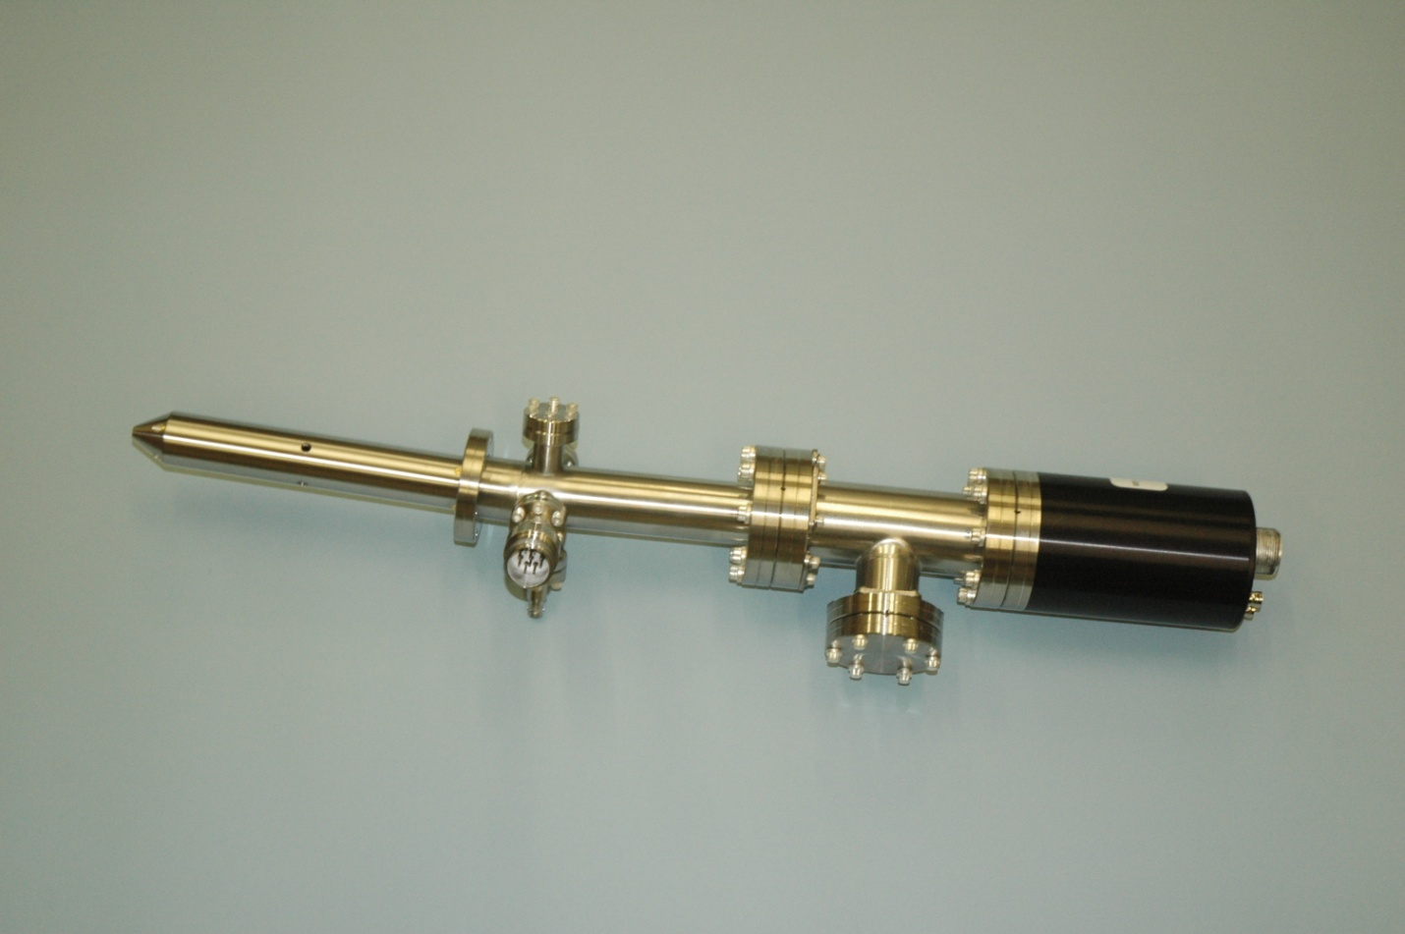

**Design Features**

* User replaceable frit ion source allowing production of various ion species
* Adjustable spot size from 75um to >1mm for spatially defined sputtering
* Continuous variable beam energy up to 5keV
* Neutral species suppression using beam bending optics
* Beam blanking capability for TOF SIMS
* Integral beam current monitoring capability
* Option beam bunching electrode
* All UHV compatible and etch resistant materials used in fabrication
* Pre-objective lens deflection for reduced spot size
* Differential pumping to minimize main chamber gas loading

Guaranteed Performance @ 5.0keV Cs Ions, 35mm W.D.

Spot size (um) Beam Current (nA) Current Density (mA/cm )

125 400 3.2

75 100 2.2

 *Nonsequitur Technologies 20664 Carmen Loop #3 Bend, OR 97702 Ph: 541-312-2410 Fax: 541-312-2412*

Model 1403Cs Schematic



System Integration Details

 *Nonsequitur Technologies 20664 Carmen Loop #3 Bend, OR 97702 Ph: 541-312-2410 Fax: 541-312-2412*